DATE:26.08.2025

EXPERIMENT – 09 Create a Snapshot of a VM and Test it by loading the Previous Version/Cloned VM using virtual box.

Aim:

To create a snapshot of a Virtual Machine in VirtualBox and test it by restoring to the previous version or cloned state.

Procedure:

1. Open Oracle VirtualBox on your host machine.
2. Select the virtual machine (VM) for which you want to take a snapshot.
3. Go to the Snapshots tab on the top-right corner of VirtualBox.
4. Click the Take Snapshot button (camera icon).
5. Provide a snapshot name (e.g., “Before Changes”) and an optional description.
6. The snapshot now saves the VM’s current state, including OS, files, memory, and settings.
7. Start the VM and make some changes, such as installing software or editing files.
8. Power off the VM.
9. In the Snapshots tab, select the snapshot you created and click Restore.
10. Start the VM to verify that it has reverted to the previous saved state, undoing any changes made after the snapshot.

Output:

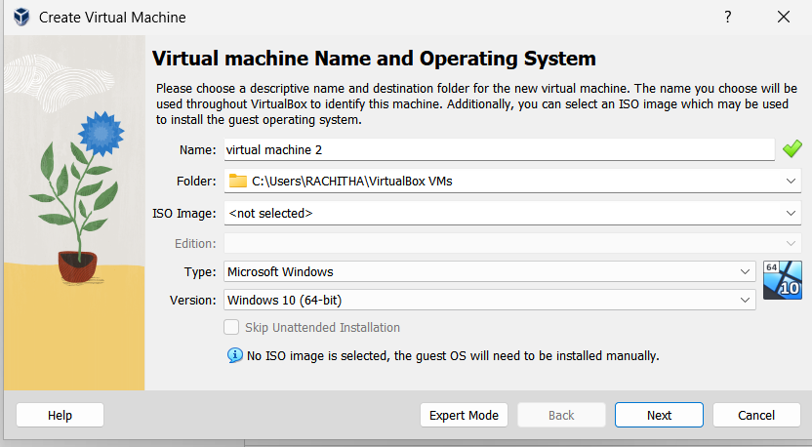

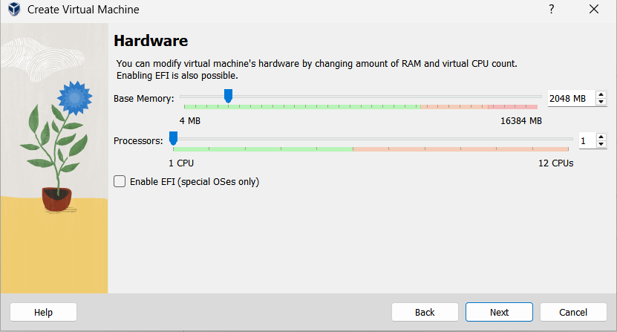

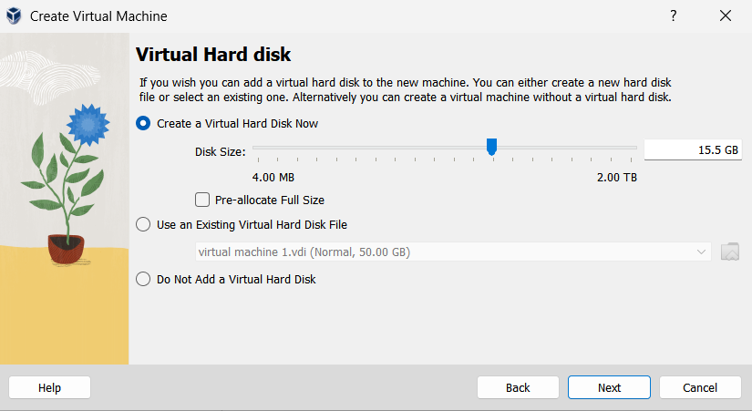

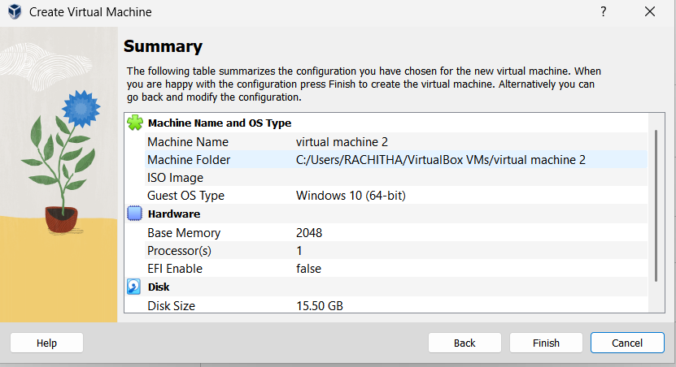

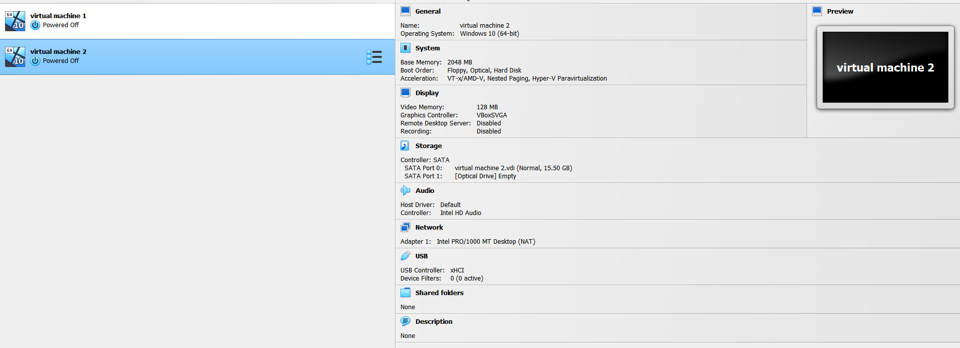

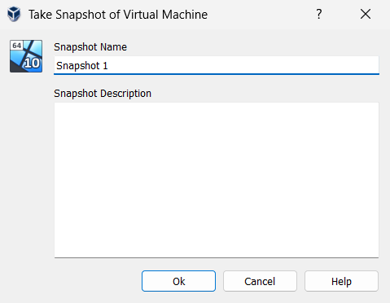

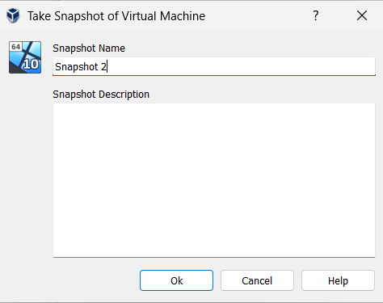

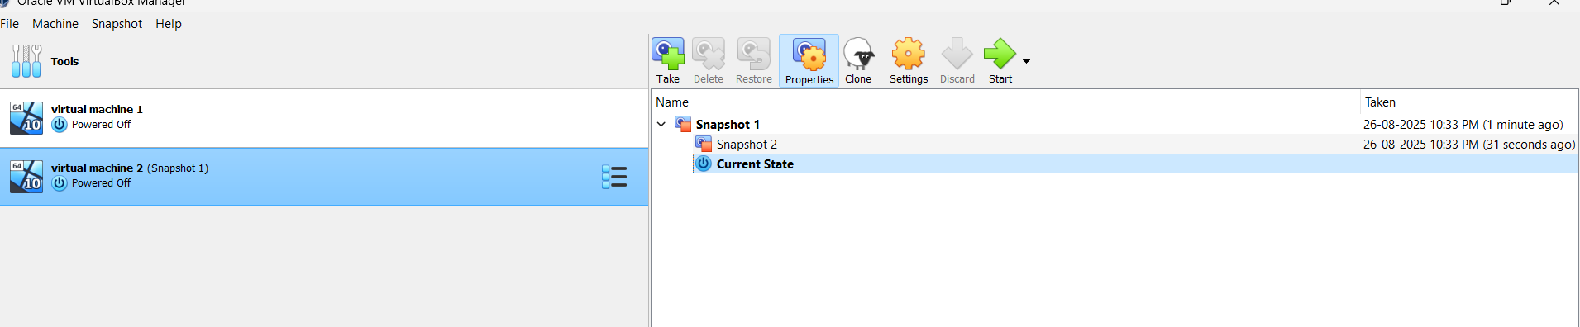

Result:

A snapshot of the VM was successfully created in VirtualBox. Restoring the snapshot reverted the VM to its previous state, demonstrating the functionality of snapshots for backup and testing purposes.